GREEN SCHOOLS
GIVING CHILDREN AN APPRECIATION OF THEIR ENVIRONMENT
AND HOW TO MANAGE IT
Green Cameroon launched its Green Media Campaign in February 2012, with the ultimate goal of increasing awareness on environmental issues and appreciation of the value and need to protect Cameroon’s natural assets. The Campaign has four major themes: Forest Management, Water Management, Agriculture and Waste Management.
Within the Green Media Campaign, one of the key target groups are the schools, as we believe that it is really important to ensure the next generation are well equipped to reverse environmental damage and understand the sustainable practices that will ensure that their children and grandchildren can also enjoy the natural wealth that Cameroon is so blessed with.
We have two programmes running in several high schools spread throughout Buea. The first is a long running Environmental Clubs Programme, to which we have welcomed a couple of new schools in recent times. In these clubs the children are encouraged to learn about their environment in a hands on way, getting out to collect and sort waste, plant trees and other plants, learn about the weather seasons, filtering water, the effects of the sun and the moon, and ways in which they can save their environment. They are also encouraged to be creative and extend their intellect, coming up with drama, poems, and convincing arguments for debates. When possible, they go on excursions to experience and see the parts of the environment that they may not have been exposed to in their usual lives. During Green Week we are looking forward to having many of the dedicated environmental club students presenting their creative inspirations, giving workshops on relevant and life changing technologies, and showing off the beautiful gardens they have helped to create within their school grounds. We hope that all of Buea will come to support and encourage these outstanding youths, and get some great tips on how they can look after themselves and their environment at the same time!
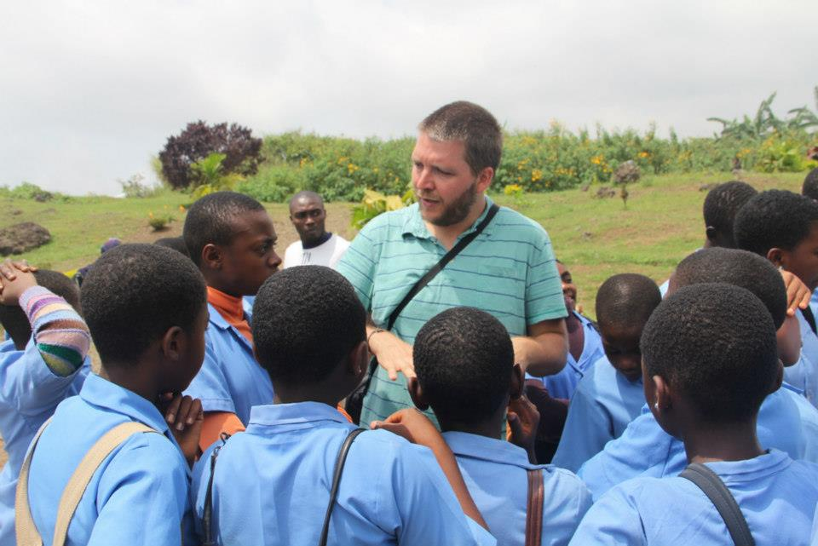
The second programme we are running is an intensive programme to allow as many students as possible to learn about our four main themes – forests, water, agriculture and waste management. This programme is running in three high schools after school hours, and we have had a fantastic response, with more than 200 students signing up! The programme involves both theory and practical aspects, and is taught by university graduates from the University of Buea, who are volunteering their time and effort to this valuable project. The programme will culminate in a gripping inter-school quiz during Green Week, where the schools will compete for a prize. The event will no doubt be tense and entertaining and we welcome as many people as possible to come and support these brilliant students as they tap the depths of their memories to come out on top!
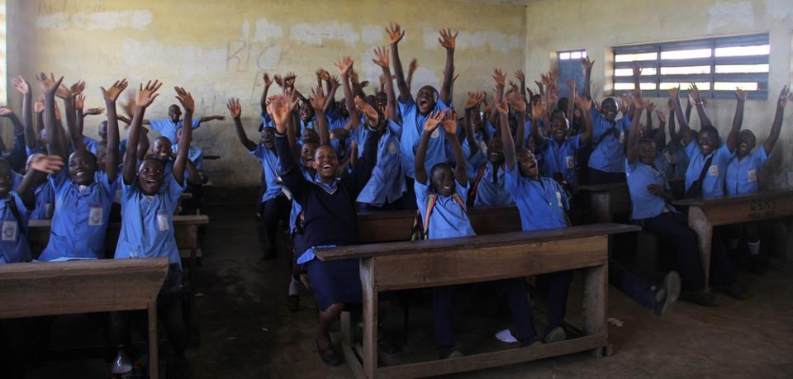
The slogan of the Green Media Campaign is BE PART OF THE CHANGE, and we hope that the people of Cameroon will join us in making the behavioural shifts needed to secure a brighter and cleaner future in this beautiful area!

